|  |  |  |  |  |
| --- | --- | --- | --- | --- |
| S.No | Test Cases | | Test Data | Expected Result |
| 1. | Unit consumed <=10 | | 6 | Not charged  40 |
| 2. | Unit consumed between 11 to 20 | | 13 | Running cost $1 per unit  40+1*3=43 |
| 3. | Unit consumed between 21 to 40 | | 32 | Running cost $2 per unit  40+10*1+12*2=74 |
| 4. | | Unit consumed >40 | 42 | Running cost $5 per unit  40+10*1+20*2+2*5=100 |

EXERCISE-2

|  |  |  |  |
| --- | --- | --- | --- |
| s.no | Test case | Test data | interest |
| 1 | Duration<=45 days | 42 days | 8 |
| 2. | Duration is >45 days &<1 year | 52 days | 8.5 |
| 3. | Duration is 1-3 year | 2 year | 9.5 |
| 4. | Duration > 3 year | 4 year | 10.5 |

EXERCISE -3

|  |
| --- |
| Less Than 1-10 1,2,9  1-> 40  2->40  9->40  Between 11-20 10,11,12 & 19,20,21  10 –> 40  11 –> 40 +1*1=41  12 –> 40+2*1=42  19-> 40+9*1=49  20->40+10*1=50  21-> 40+10*1+1*2=51  Between 21 –40 22 & 39,40,41  22-> 40+10*1+2*2=54  39=40+10*1+19*2=88  40= 40+10*1+20*2=90  41= 40+10*1+20*2+1*5=95  Greater >40 41 |

Exercise 4

Conditions

|  |
| --- |
| C1 – Single  C2- Married Joint Return  C3- Married Separate Return  C4- >65 years  C5- Blind |

Action =25=32

CONDITIONS-5

C1-

C2-

C3-

C4-

C5-

|  |  |  |  |  |  |  |  |  |  |  |  |  |  |  |  |  |  |  |  |  |  |  |  |  |  |  |  |  |  |  |  |
| --- | --- | --- | --- | --- | --- | --- | --- | --- | --- | --- | --- | --- | --- | --- | --- | --- | --- | --- | --- | --- | --- | --- | --- | --- | --- | --- | --- | --- | --- | --- | --- |
| R1 | R2 | R3 | R4 | R5 | R6 | R7 | R8 | R9 | R10 | R11 | R12 | R13 | R14 | R15 | R16 | R17 | R18 | R19 | R20 | R21 | R22 | R23 | R24 | R25 | R26 | R27 | R28 | R29 | R30 | R31 | R32 |
| T | T | T | T | T | T | T | T | T | T | T | T | T | T | T | T | F | F | F | F | F | F | F | F | F | F | F | F | F | F | F | F |
| T | T | T | T | T | T | T | T | F | F | F | F | F | F | F | F | T | T | T | T | T | T | T | T | F | F | F | F | F | F | F | F |
| T | T | T | T | F | F | F | F | T | T | T | T | F | F | F | F | T | T | T | T | F | F | F | F | T | T | T | T | F | F | F | F |
| T | T | F | F | T | T | F | F | T | T | F | F | T | T | F | F | T | T | F | F | T | T | F | F | T | T | F | F | T | T | F | F |
| T | F | T | F | T | F | T | F | T | F | T | F | T | F | T | F | T | F | T | F | T | F | T | F | T | F | T | F | T | F | T | F |
| P | P | P | F | P | P | P | F | F | F | F | F | F | F | F | F | P | P | P | F | P | P | P | F | F | F | F | F | F | F | F | F |

|  |
| --- |
| RESULT |

EXERCISE 5

2

Manager verifies as per conditions

Employee apply for leave

1 3

4

Independent paths

1-2-3

1-2-4

EXERCISE 6

Checks conditions

Fills the form

1 2 3 4

No of days

5

Independent paths

1-2-3-4

1-2-3-5

EXERCISE-6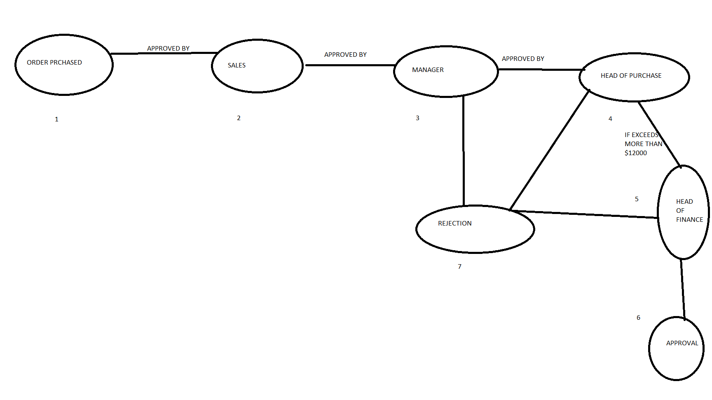

Indpendent paths :

1-2-3-4-5-6

1-2-3-7

1-2-3-4-7

1-2-3-4-5-7

ORTHOGONAL ARRAY EXAMPLES

EX-1

VARIABLES VALUES

SECTIONS – TOP MIDDLE BOTTOM

VISIBILITY- SHOWN HIDDEN

BROWSER- IE FIREFOX

SERVER- IIS APACHE WEBLOGIC

MAX VALUE=3

MAX VARIABLE=4

Combination=34

L(9)

Ex-2

Variables values

Operating system – windows,XP,Unix,Linux

Viewed – IE,Google,netscape

Mode- admin,user